auDA Quarterly Report Q3 2024-25

**January, February, March**

We acknowledge the Traditional Custodians of country throughout Australia and their connections to land, sea and community. We pay our respect to their elders past and present, and extend that respect to all Aboriginal and Torres Strait Islander peoples today.

Contents

From the CEO, page 3

Quarter at a glance, page 6

.au by numbers, page 7

.au scorecard, page 8

From the CEO

In Q3, auDA was pleased to carry out a range of activity to benefit Australian internet users, including announcing funding for 15 projects through the Community Grant Program. The projects span innovations for remote teachers and students, climate smart farming, and Aboriginal and Torres Strait Islander data sovereignty. We also announced the auDA Churchill Fellowships, a new initiative to provide funding for individuals to uplift the utility of the internet for Australians through research. The inaugural auDA Churchill Fellows will be announced in September 2025.

During the quarter, auDA staff and Board Directors progressed work on a new auDA strategy for 2026-30, with consideration for auDA’s operating environment, opportunities and challenges. We look forward to sharing a Draft Strategy for public consultation in Q4.

Meanwhile, in March, the Australian Government concluded its periodic review of [auDA’s Terms of Endorsement](https://www.auda.org.au/about-auda/corporate-governance/terms-of-endorsement/) (ToE), which included public consultation. The revised ToE include minor amendments that reflect auDA’s role in internet governance regionally. auDA welcomes the updated ToE and the Government’s shared commitment to a resilient .au and multi-stakeholder internet governance model.

**Core functions**

The ToE set out our core functions to operate a secure, reliable .au domain; administer the .au licensing regime through multi-stakeholder processes; and support multi-stakeholder internet governance domestically, regionally and internationally.

Security and continuity planning are essential to support an uninterrupted .au DNS. In the quarter, we began preparations for our annual ISO 27001 audit, the international best practice standard for information security management systems. This supports auDA’s efforts to deliver a resilient .au, alongside proactive monitoring of the evolving threat environment.

This year, auDA will undertake a review of the .au Licensing Rules. The rules are developed through multi-stakeholder consultation to ensure they meet the changing needs of Australian internet users. In the quarter, we sought community feedback on an [Issues Discovery Paper](https://www.auda.org.au/consultations/call-for-feedback-issues-discovery-paper/) to inform the Terms of Reference for the multi-stakeholder Policy Advisory Panel that will lead the review. In the coming quarter, we will call for expressions of interest to form the Policy Advisory Panel.

Creation of new .au domain names in Q3 increased 5.6 per cent year-on-year, showing that .au continues to be valuable for Australians when building their online presence. Complaints lodged with auDA about domain names that may not comply with .au rules also increased in the quarter. Of 575 complaints received, 361 related to suspected misuse of another business’ legal information to register a .au. Following review by auDA, 88 per cent of cases resulted in the suspension of related domain names. Following suspension, if the compliance issue is not addressed within 30 days, the domain licences are cancelled. Clear, consistent complaint processes, as set out in the .au Licensing Rules, help us act on misuse of domain names to deliver a trusted .au.

As active participants in multi-stakeholder internet governance, we engaged with local, regional and international communities this quarter. In Australia, we worked with the Australian Internet Governance Forum (auIGF) Multi-stakeholder Standing Committee in our capacity as Secretariat to prepare for the 2025 auIGF in Adelaide on 23-24 September 2025. Regionally, we participated at the 87th meeting of the Asia Pacific Top Level Domain (APTLD87), where we delivered an exercise on crisis management and joined panels on the value of strong licensing rules and business continuity during crises. On the global stage, we participated in the 82nd meeting of the Internet Corporation for Assigned Names and Numbers (ICANN82) where we continued our contributions in the Country Code Names Supporting Organisation (ccNSO) Council and key committees. We also met with registrars, registries and members of the Technical Community Coalition for Multistakeholderism (TCCM) to continue strengthening multi-stakeholder internet governance.

**Community engagement**

We kept up our comprehensive program of engagements with .au members and stakeholders in Q3. auDA sponsored and participated in events held in Melbourne, Canberra, Tasmania, Queensland and online. These included sessions on internet governance for university students, and information on .au and website security for refugee and migrant women through the *SisterWorks Small Business Program*.

In February 2025, we proudly sponsored the Tech Futures 2025 event at Parliament House, delivered by the Tech Policy Design Institute (TPDi). There I joined leaders from government, civil society, academia and industry, advocating for the role of .au and the development of strong and inclusive tech policy in Australia.

During the quarter, we hosted a series of webinars for information sharing with the .au registrar community. We also delivered the latest round of our Co-Marketing Program, which provides funding to registrars to support .au registrations and a competitive .au market. This financial year, the Program has provided almost $800,000 in funding.

In Q3, we also consulted with the public on a [Draft Conduct Complaints Policy and Draft Engagement Charter](https://www.auda.org.au/consultations/public-consultation-on-conduct-complaints-policy-and-engagement-charter/) to support constructive engagements with auDA. The outcome of the consultation will be shared on our website in Q4.

I thank the auDA team and our many stakeholders for their work and engagement over the quarter. Finally, I welcome Sharon Copeland-Smith, who joins the Executive team as our Chief Operating Officer, and Robert Turney, auDA’s new Chief Information Security Officer. We’re delighted to have them join the auDA team.

**Celebrating .au direct**

March marked the three-year anniversary of .au direct, launched in 2022 to support greater choice for Australians building their online presence. Since its launch .au direct has become a popular choice, making up one in five of all .au registrations. Other notable statistics include:

* 768,045 .au direct domain names are registered,
* 7.6 million DNS queries per day for .au direct in 2024,
* .au direct domain names are on average 26% shorter than com.au domain names.
* The top user groups in .au direct are: 87% businesses including sole traders, 8% clubs, associations and community groups, 3% individuals.

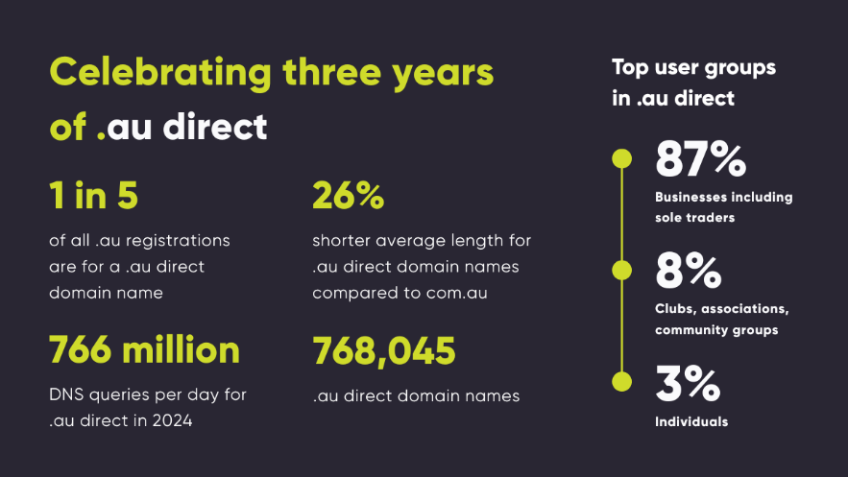

**Dr Bruce Tonkin, auDA CEO**

Quarter at a glance

**Timeline of key milestones and events**

**January**

* Bruce Tonkin commenced as auDA CEO
* Opened consultation on Draft Complaints Policy and Engagement Charter
* Published auDA Sustainability Framework
* Published .au Product Guide for registrars
* Opened Co-Marketing Program grant round applications
* Technical Advisory Standing Committee meeting

**February**

* Announced 2024 Community Grant projects and hosted celebration event
* auDA Board meeting
* Published Why .au? report and hosted webinar
* Opened applications for Nomination Committee
* Announced auDA Churchill Fellowships
* Opened consultation on .au Licensing Rules Issues Discovery Paper
* Sponsored Tech Policy Design Institute (TPDi) Tech Futures event
* Participated at APTLD87
* Nomination Committee meeting
* auDA team planning retreat

**March**

* Australian Government released revised Terms of Endorsement
* .au membership events in Tasmania, Queensland and Canberra
* edu.au Advisory Committee meeting
* 39 year anniversary of .au, the 10th largest top level domain globally
* Published Internet Governance Roadmap 2025 Progress Report
* Participated at CIRA Technical Community Summit and ICANN82
* Three year anniversary of .au direct
* Launched Aussies get it campaign
* Hosted ICANN82 debrief webinar

.au by numbers

**Overview of core function metrics**

Variations are year-on-year

**.au registrations**

4,260,259 domain names under management, March 2025 (up 0.2%)

152,229 new domain names created in Q3 2024-25 (up 5.6%)

**Security**

30 registrars with ISO 27001 certification or equivalent at end of Q3 2024-25

1 registrar with ISO 27001 progress plan in place at end of Q3 2024-25

auDA completes an annual Baseline Security Audit program with registrars

**DNS and registry services**

75,600 average .au DNS queries per second, down 2.6 per cent

100% DNS availability

100% WHOIS availability

100% registry database availability

**Compliance activity**

906 enquiries (up 33%)

575 complaints (up 149%)

11 auDRP disputes (0% change)

7,846 compliance audits (up 67%)

20 enforcement body requests (up 25%)

284 DNS abuse reviews (up 6%)

**Members**

5,584 at 31 March 2025 (up 13%)

194 new members in Q3 2024-25

**Engagements**

Three .au registrar briefings

10 .au member events, workshops and sponsorships

Three auDA webinars

.au scorecard

**Overview of strategic objectives and key results as at 31 December 2024**

**Trust**

Trust objective 1 is to drive down DNS abuse. The key result is to reduce .au domain names with an instance of DNS abuse down to 0.005 per cent by 30 June 2025. Status of this objective is on track.

Trust objective 2 is to drive up the integrity of the .au domain. The key result is for 99 per cent of new .au registrations and 92 per cent of .au renewals have a validated Australian presence by 30 June 2025. Status of this objective is on track.

Trust objective 3 is to lead the world’s best practice country code Top Level Domain security. The key result is for 100 per cent of registrars to have ISO 27001 certification or equivalent by 30 June 2025. Status of this objective is on track.

**Innovation**

Innovation objective 1 is to improve the utility of the .au by providing greater choice of .au domain names. The key result is to have .au direct names account for 18 per cent of total .au domain names by 30 June 2025. Status of this objective is on track.

Innovation objective 2 is to invest to enable innovation and research by others. The key result is $2.2 million invested in innovation initiatives by 30 June 2025. Status of this objective is on track.

**Multi-stakeholder engagement**

Multi-stakeholder engagement objective 1 is to grow auDA’s membership. The key result is 6,000 .au members by 30 June 2025. Status of this objective is on track.

Multi-stakeholder engagement objective 2 is to increase auDA’s influence in multi-stakeholder internet governance. The key result is to actively participate at 40 key international and domestic internet governance and policy forums by 30 June 2025. Status of this objective is on track.

**People**

People objective 1 is to build an organisation regarded as a great place to work. The key result is to maintain or improve the annual culture survey result by 30 June 2025. Status of this objective is on track.

**Governance**

Governance objective 1 is to strive for excellence in our reporting. The key result is to engage an external body to conduct an assurance readiness review of the 2024-25 Annual Report. Status of this objective is on track.